Report

# **Screen shot ERD:**

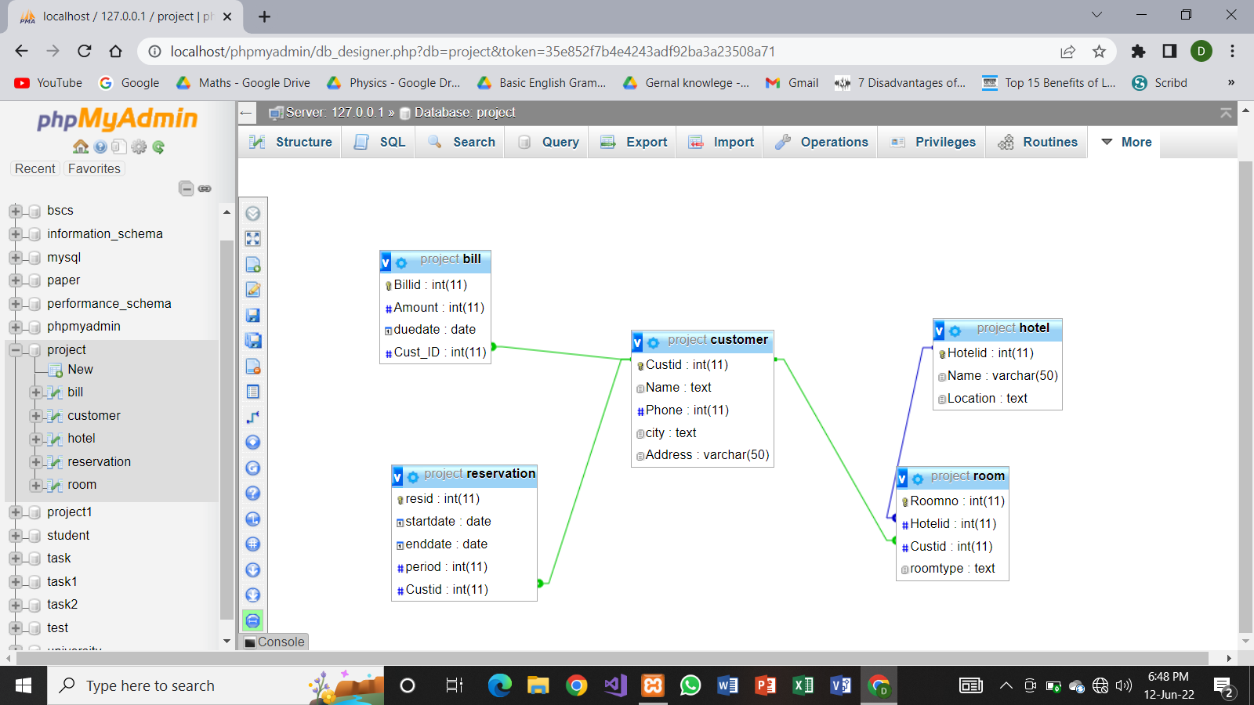

# **Relational Schema:**

Bill: bill id, Amount, due date, Cust-Id

Customer: Cust id, Name, Phone, City, Address

Hotel: Hotel id, Name, Location

Reservation: res id, start date, end date, period, Cust id

Room: Room no, Hotel id, Cust id, room type

# **Screen shot Database:**

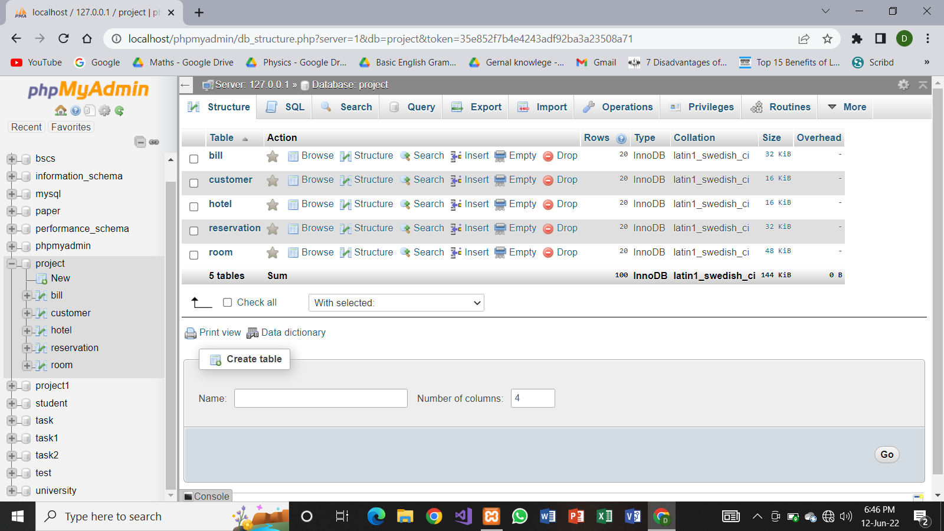

# **Screen shot table bill:**

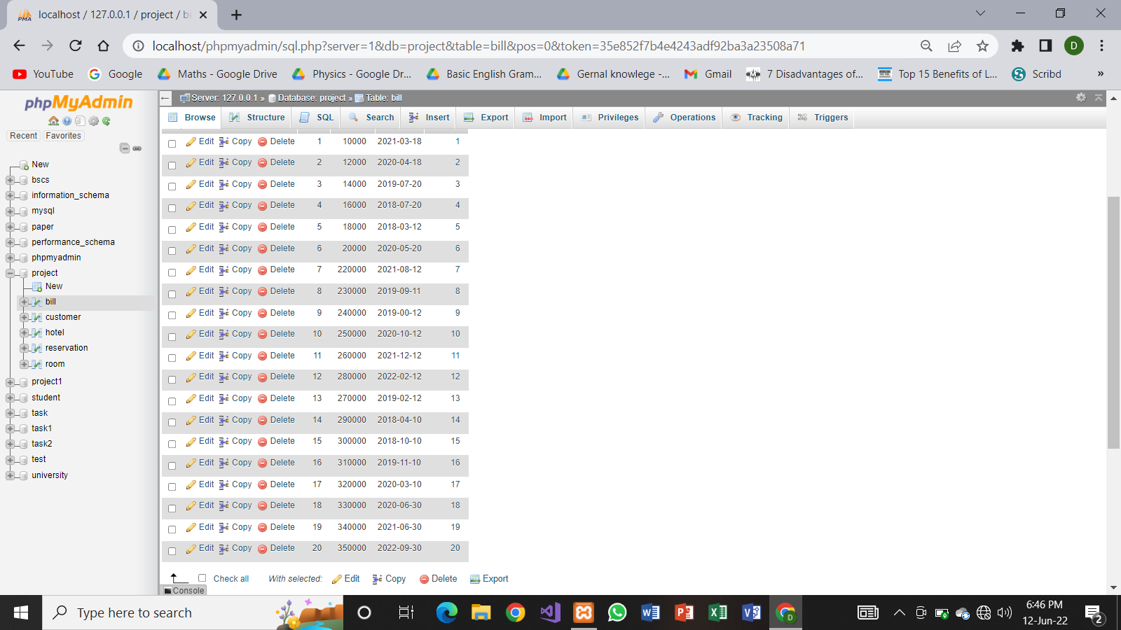

# **Screen shot table customer:**

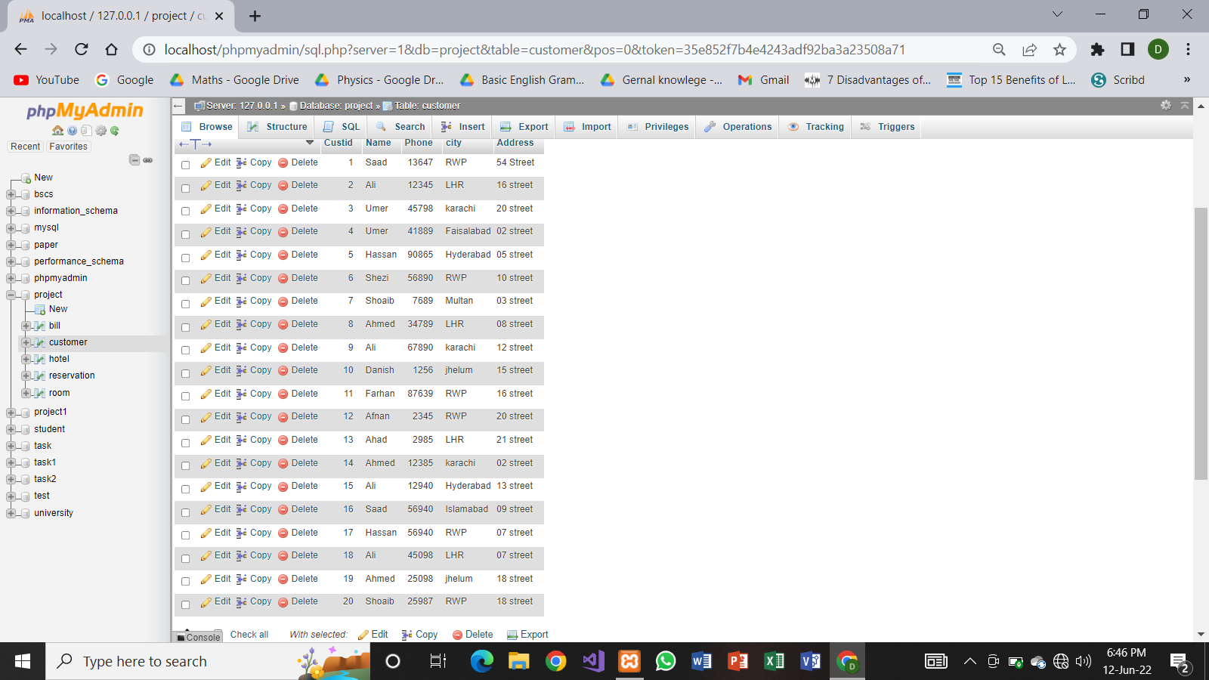

# **Screen shot table hotel:**

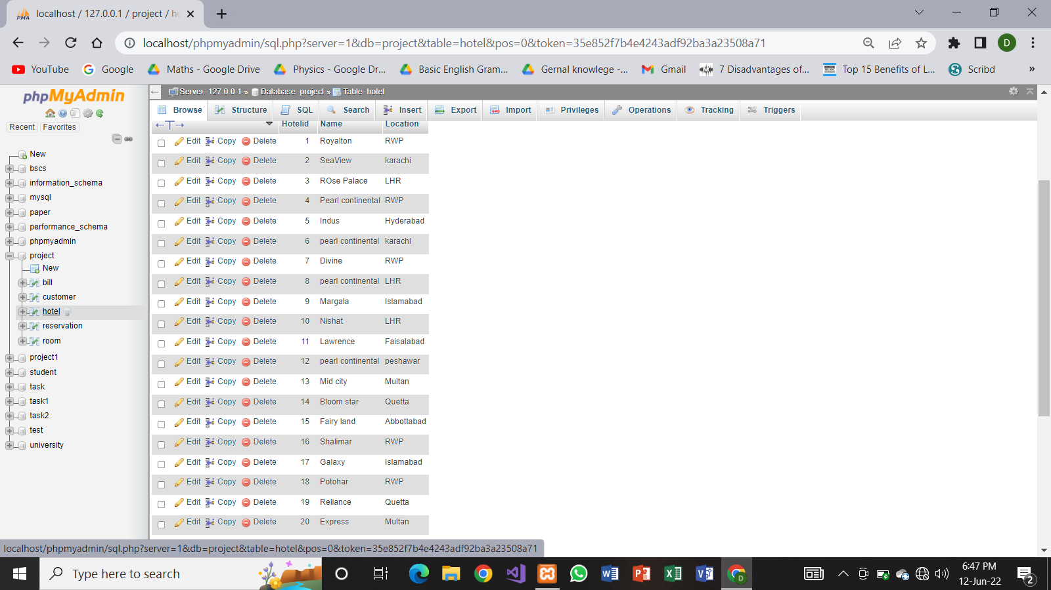

# **Screen shot table reservation:**

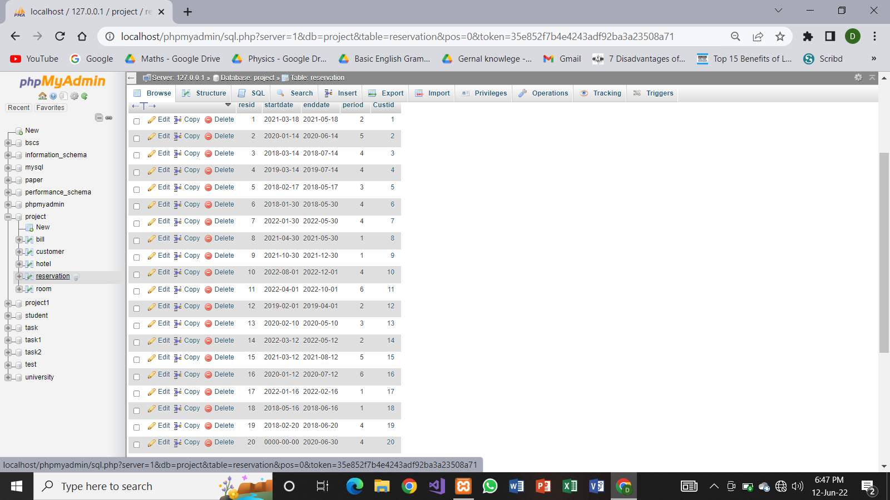

# **Screen shot table room:**

